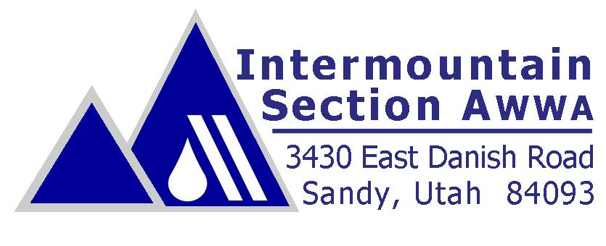

February 15, 2012

Dear Mayor…

A safe, reliable water supply is critical to the success of any community. It creates jobs, attracts industry and investment, and provides for the health and welfare of citizens in ways ranging from disease prevention to fire suppression. We often take water supply for granted until it is threatened, either by drought, water main breaks, or some other event. In 2007, in an effort to promote the importance of this precious resource, then governor Jon Huntsman Jr. signed legislation designating a state-wide water week, declaring the first full week in May as **Water Week**. Water Week provides a unique opportunity for both water professionals and the communities they serve to join together to recognize the vital role water plays in our daily lives.

For the past six years the Intermountain Section of the American Water Works Association (IMS-AWWA) has been helping to organize events throughout the State to celebrate Water Week. We are pleased to announce the Theme for Water Week 2012:

**“Water: A Natural Wonder”**

Water Week will include many great activities such as water fairs, film screenings on PBS stations, programs in your local library, a golf tournament to benefit Water For People, poetry, photo and poster competitions and more. See the website [www.waterweek.org](http://www.waterweek.org) for additional activities and event details.

AWWA would like to encourage more involvement in Water Week from cities and towns such as yours. This is an opportunity to showcase the great work your water department or local water agency is doing. This is also an opportunity to get citizens involved in programs that educate and build better communities.

To help get you started, IMS-AWWA is providing to you a package of materials to assist you with planning your own Water Week activities. This package contains the following:

1. Water Week Poster based on this years theme . We ask that you post this in a noticeable location in your City Hall.
2. A sample “Mayor’s Proclamation” designating the first week in May as Water Week. This can be presented during a City Council meeting or other such meeting.
3. Radio Public Service Announcements that you can request be played on your local radio station.
4. Banner Ad which can be placed on your website promoting Water Week.
5. Sample Press Release that you can submit to your local news outlets.
6. Children's Activity Pages. These activity pages for kids can be used for school presentations or at any community event.

AWWA encourages you to do the following:

* Meet with your water department or local water agency to identify ways you could celebrate Water Week in your community.
* Put water week on your city calendar. This could be done in conjunction with presentation of the Water Week Proclamation and other official action in a Council Meeting.
* Help us promote water week participation by announcing water week in your newsletter or including a link to the water week website on your city website.

If you have additional ideas or would like to further support Water Week activities please contact Jared Oldroyd at [Joldroyd@bowencollins.com](mailto:Joldroyd@bowencollins.com) or one of the other Water Week volunteers through the e-mail addresses listed on the website ([www.waterweek.org](http://www.waterweek.org)).

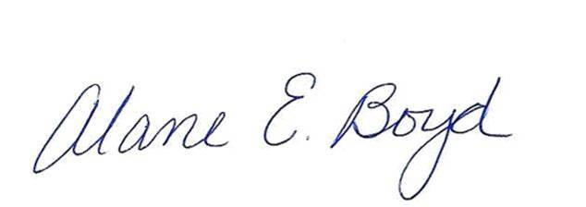Sincerely,

Alane E. Boyd, P.E. David Richards, P.E.

Executive Director Intermountain Section Chair